**Information and Database Management Systems (IDBMS)**

**Lab Assignment #3**

Consider a modernized version of Microsoft's *Northwind* database. *Northwind* is a fictitious store that sells specialty food products from all over the world. The database has 5 tables. Below is an Entity Relationship Diagram (ERD) which shows the tables and their relationships.

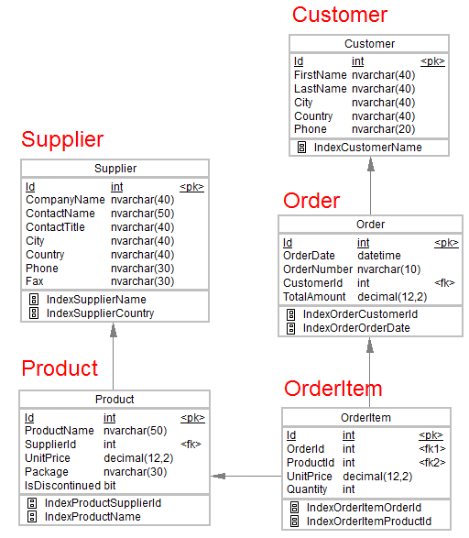

Here, <pk> represents the primary key and <fk> is foreign key. The domain set of each attribute is given the figure itself.

1. Create the tables for the given database using CREATE TABLE statement in MySQL.
2. Specify the primary key and referential integrity constraints in each table.
3. Specify the NOT NULL constraint on the following columns of each table:

Customer (FirstName)

Order (OrderDate)

Product (ProductName, IsDiscontinued)

Supplier (CompanyName)

The other columns may have NULL values.

1. Specify the default value of following columns using DEFAULT constraint:

Order (TotalAmount = 0)

OrderItem (UnitPrice = 0)

OrderItem (Quantity = 1)

Product (UnitPrice = 0)

1. Specify a UNIQUE constraint on the column *CompanyName* in Supplier table.
2. Specify a CHECK constraint to ensure that the value of *UnitPrice* in *Product* table must be greater than or equal to the value of *UnitPrice* in *OrderItem* table.
3. Populate the data in tables from the attached .xls files using INSERT INTO statement in MySQL.

Customer Table: customer.xls

Supplier Table: supplier.xls

Product Table: product.xls

Order Table: order.xls

OrderItem Table: orderitem.xls